The Design Proposal Document – OOP Software to Support Operation of a Humanoid Robot
Introduction
The usage of humanoid robot is increasing and being integrated to where human – robot collaboration is essential including industries like automobile, manufacturing, service and healthcare. It is challenging task to design a robot behavior, cogitative ability, appearance and social skills (Mukherjee, D.et al. (2022). The humanoid robots are designed for multipurpose. Human characteristics like dexterity and adaptability helps to perform wide range of activities. Robotic systems often involve a mix of diverse hardware components operating across various platforms, some of which demand precise real-time communication. In essence, building a robotics programming library is far from straightforward. While object-oriented programming can help abstract some of the underlying complexity, achieving a balance between conflicting design objectives often requires careful compromise (Rickert, M. and Gaschler, A. (2017). Utilizing the power of Artificial Intelligence, the humanoid robot will be able to learn and adapt various environment. (Peter-hanbury 2025,). This document covers designing and development of software that support operation of humanoid robot and simulating the core operations that robot that robot might perform with object orient programing in python with command line interface (CLI) for human interaction.
System requirements and specification
This system is designed to enable a humanoid robot to function effectively as a reception assistant in a smart office environment. The design decisions were informed by the principles of object-oriented programming (OOP), human-robot interaction (HRI), and the need for environmental awareness in collaborative robots (Mukherjee et al., 2022).
Object-Oriented Design
The system employs Python’s object-oriented features to encapsulate distinct functionalities. Each class represents a real-world component—such as visitors, navigation, or sensors. This approach supports modularity, scalability, and ease of testing, which are crucial in real-world robotics applications (Ackerman, 2023).
Selected Operations
The three operations—greeting visitors, guiding them to rooms, and monitoring the environment—were chosen based on common use cases in service robots (Mulko, 2023). Greeting involves interaction, which is central to Human Robot Interaction. Navigation reflects spatial awareness, while environmental monitoring supports safety and adaptation.

User Interface Design
The command-line interface provides a simple but effective way to simulate Human Robot Interaction. A text-based menu allows users to input commands and receive feedback. This design keeps the system lightweight and accessible during development while aligning with CLI principles used in early-stage robotics testing environments.
Environment Simulation
The back-end generates pseudo-random environmental data to simulate sensory input, enabling the robot to respond appropriately (e.g. Behavior based on temperature or noise). This reflects how real robots interpret data from IoT-connected sensors.
Use of Data Structures
Efficient robot software relies heavily on data structures to organize, store, and quickly access complex information like sensor data, environmental representations, and robot positions (Majcherczyk, N. and Pinciroli, C.2020). A list stores all past visitor interactions, allowing for future enhancements like visitor recognition or analytics. A queue manages visitors in a first-come, first-served order—mimicking how appointments work. A stack manages alerts, allowing the robot to respond to the most recent urgent messages first (e.g., fire alarm override).
System States and Behavior
The robot transitions between states such as idle, engaged, and guiding based on inputs and context. This state management is visualized in the state transition diagram and helps ensure robust behavior even in dynamic environments.
Functional requirements of the application
The humanoid robot application will incorporate several components outlined below:
- The application shall prompt user to enter name and save in its database.
- The system shall able to validate name against a list of names from preloaded appointment list (Queue).
- The application shall log the visitor’s name and time of the visit in list structure.
- The system shall stimulate greeting visitors.
- The system shall return to idle after completing navigation to visitors and record each visitor’s interaction in a log (python list).
- The system shall allow retrieval and display of past visitor log and from the list.

Use of Data structure
List : Record and maintain visitors’ information in logs for recognition and analytics.
Stack : Validate visitors name from pre-loaded appointment list
Queue: manages alerts allow system to respond to messages.

UML Diagrams
Unified Modelling Language (UML) is a visualization of different pieces of software applications. It offers consistent way to visualize facets of software designs (Carnes, B. (2021). Class diagram, Activity diagram, Sequence diagram, and State diagram are the most widely used types of UML.

- Class Diagram
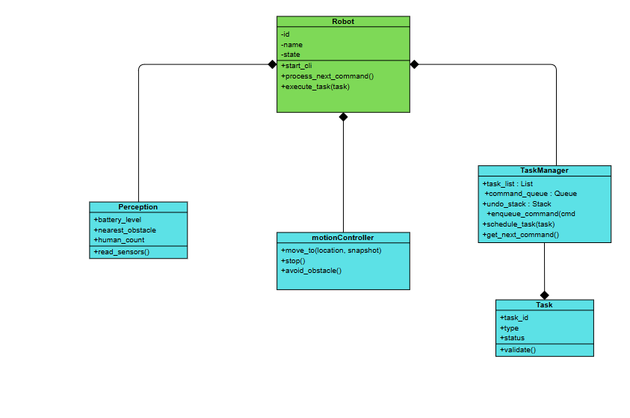

2. Activity Diagram

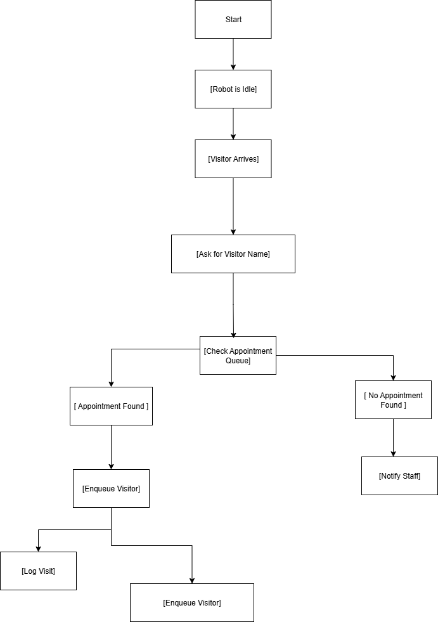

3. State Diagrams

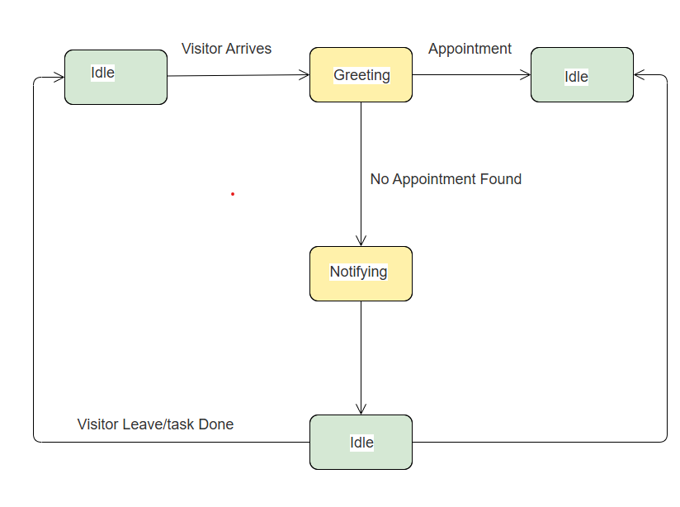

4. Sequence Diagram

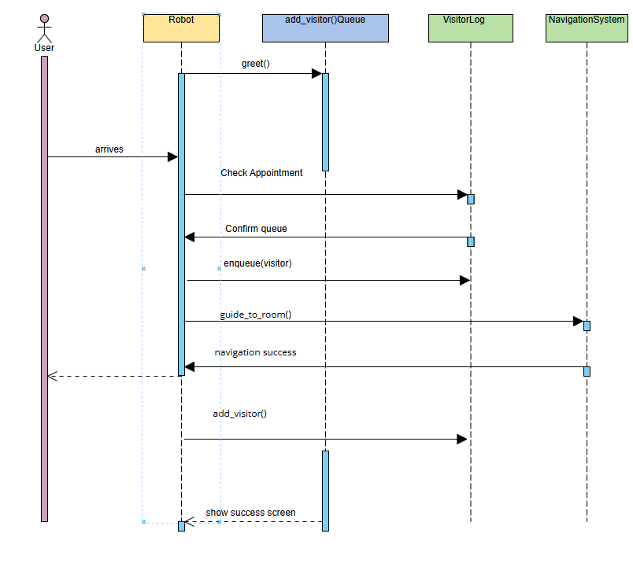

Reference

- Mukherjee, D.et al. (2022) A Survey of Robot Learning Strategies for Human-Robot Collaboration in Industrial Settings. Robotics and computer-integrated manufacturing 73102231-.
- Ackerman, E 2023, Humanoid Robots Are Getting to Work - IEEE Spectrum, spectrum.ieee.org.
- Mulko, M 2023b, Humanoid Robots Are Getting to Work - IEEE Spectrum, spectrum.ieee.org.
- Rickert, M. and Gaschler, A. (2017). Robotics library: An object-oriented approach to robot applications. [online] IEEE Xploredoi: https://doi.org/10.1109/IROS.2017.8202232.
- Peter-hanbury 2025, https://www.bain.com/fr/our-team/arjun-dutt & https://www.bain.com/our-team/emanuele-veratti 2025, Humanoid Robots at Work: What Executives Need to Know, Bain.
- Carnes, B. (2021). UML Diagram Course – How to Design Databases and Systems. [online] freeCodeCamp.org. Available at: https://www.freecodecamp.org/news/uml-diagrams-full-course/.
- Majcherczyk, N. and Pinciroli, C. (2020). SwarmMesh: A Distributed Data Structure for Cooperative Multi-Robot Applications. arXiv (Cornell University), [online] 6, pp.4059–4065. doi: https://doi.org/10.1109/icra40945.2020.9197403.

